Transmission Gate
Introduction:
Since, nMOS acts as a perfect switch for logic 0 and pMOS acts as a perfect switch for logic 1. A transmission gate contains a combination of both. Hence, a transmission gate is used to pass both logic 1 or logic 0 without degradation.

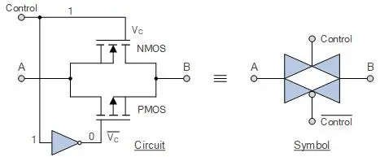
Image: Circuit diagram and Circuit Symbol of Transmission gate

Working:
When logic 1 is applied to control signal, nMOS turns ON and due to inverter connected to pMOS, pMOS receives logic 0 and it also turns on. If source is connected to logic 0 then nMOS acts as perfect switch and if source is connected to logic 1 then pMOS acts as a perfect switch and signal is transferred from source to drain without degradation. When logic 0 is applied to control signal, both the transistors turns off leaving the output unconnected from the input. This creating the state of high impedance (Z).

Transmission Gate Truth Table:
Input | Control | Output
1 | 1 | 1
0 | 1 | 0
1 | 0 | Z
0 | 0 | Z

Circuit Diagram:
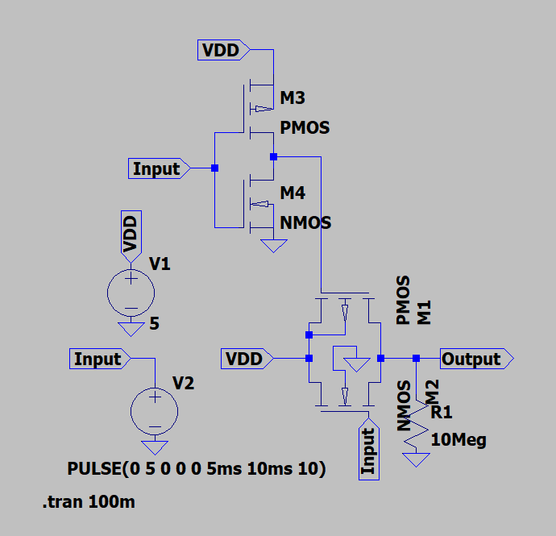
This simulation is performed on LTSpice

Simulation Result:
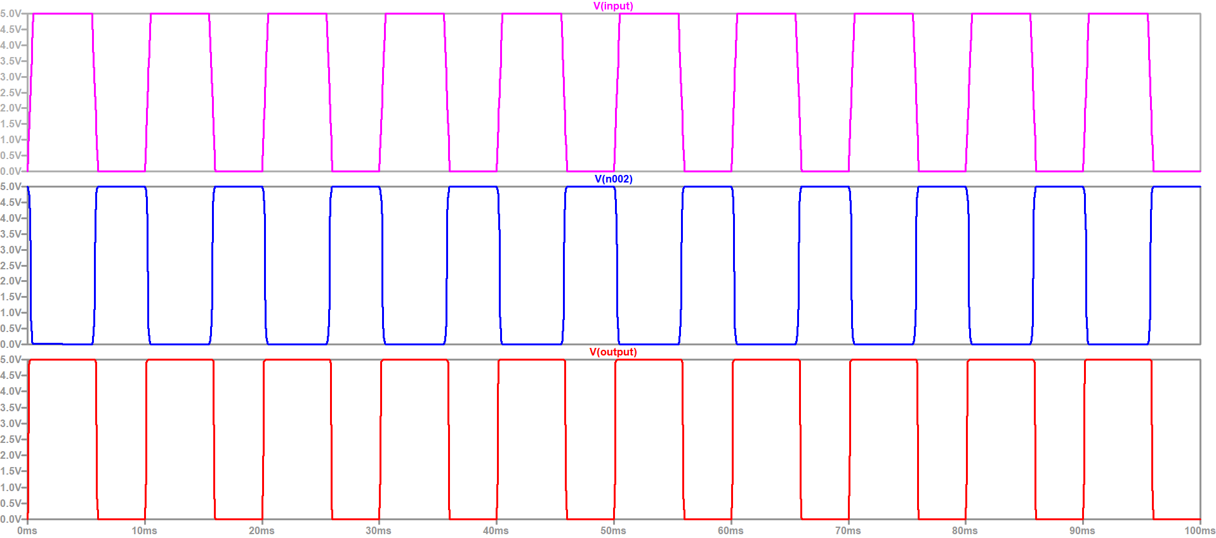

Explanation:
The upper portion of circuit contains the CMOS inverter and lower portion contains the transmission gate. Source of both the transistors is connected to VDD. In simulation, first waveform represents the input, second waveform represents the inverted input that is supplied to gate of pMOS and third waveform represents the output.

Challenges Faced:
Currently I am unfamiliar with the bulk pin of the transistor. I connected bulk pin wrongly many times. I tried to create a symbol for the CMOS inverter to simplify the transmission gate circuit, but it was not working. I will try it again. I forgot to pull down the output which was leading to incorrect results.
I learned that bulk pin of nMOS should be connected to ground and that of pMOS should be connected to high voltage, but for a standard MOSFET we have only three pins and this bulk pin is connected to the source pin inside the housing and hence can not be connected somewhere else. As learned from google, for making transmission gates ICs are used in which bulk of all nMOS transistors is connected to ground/ lowest voltage and bulk pin of all pMOS transistors is connected to VDD/ highest voltage.

Author:
MADHUSUDAN

